Choosing the Right Interior Paint Color
Choosing the right paint color for interior painting can be a daunting task. Here are a few tips of the trade!
- Understand your decorating style and what inspires you.
- Research on pintrest, Instagram, google and the like, to determine what styles and configurations you like to see in the prospective room. Don’t be afraid to think outside the box!
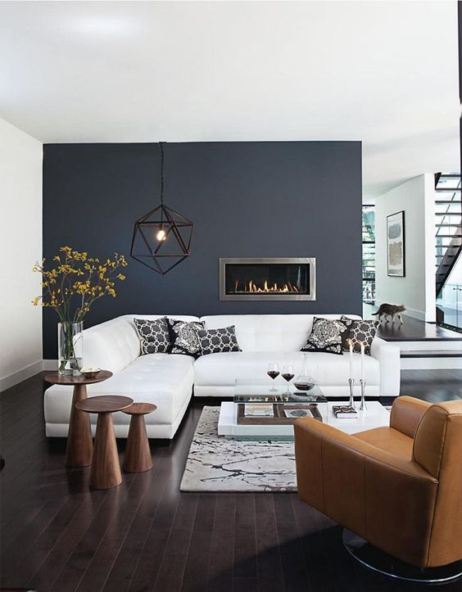
- Pick your color based on décor and focal points.
- Choose a color that enhances the beauty of the décor in the room. Take some time to inspect the various colors in your decorative rug, wall hangings, furniture, etc. and play off those. In the image below the focal point is the wooden beams and doors.
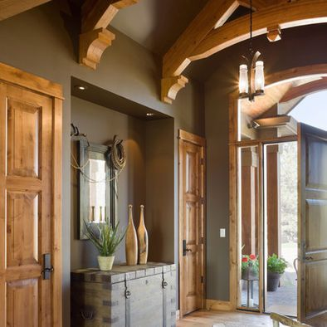

- Neutrals are safe, reliable and sometimes the best choice.
- Neutral colors often times are the best at enhancing the features in your home
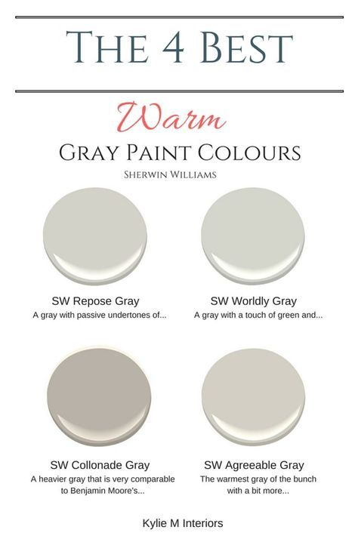
- Make use of Sherwin Williams Color Visulizer.
- Snap of photo of the room you like painted and upload it to the visualizer. SW Color Visualizer
- Remember when using this tool it will not be an exact representation of how your room will look. The lighting in the room and the sheen you choose will play a big part in how your colors will present.
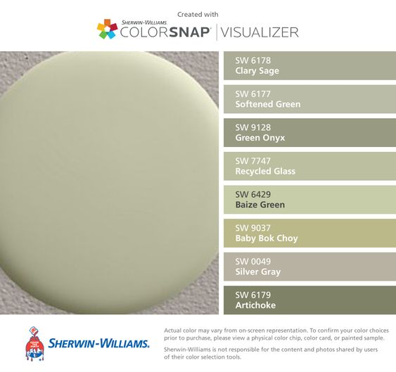
- Purchase samples of 3 of the main colors you feel are a good fit.
- Apply the samples on 3 separate poster boards so that you can move them around the room at different times of the day and night. Again, natural and artificial lighting will play a huge role in how the color will present.
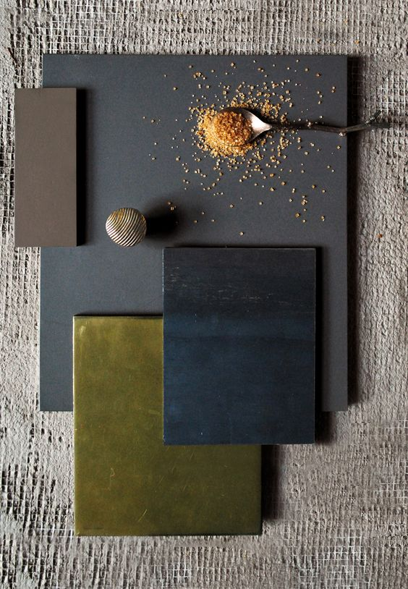

Are you planning an interior painting project in Memphis TN? Give Riggins Painting a call or request online for an estimate!

